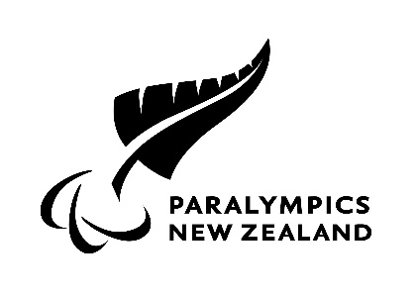
Updated 25 August 2020

APPENDIX 1
PNZ COVID-19 PANDEMIC – HEALTH QUESTIONAIRE AND HEALTH AND SAFETY INDUCTION CONFIRMATION

The Induction process will involve reading and understanding of the PNZ Health and Safety Plan and where appropriate those for external HPSNZ and other training facilities, on the health risks associated with COVID-19 and key exposure and transmission risks; the safety measures in place to mitigate those risks; and wellbeing considerations.

Confirmation of induction and health status will be collected on the form. If the answer to any of these questions is yes, the individual concerned must obtain a written medical clearance and provide that clearance to PNZ, prior to returning to work or training.

Prior to entering the PNZ Auckland office, other office spaces, HPSNZ and other training facilities for the first time following a COVID-19 related closure, everyone will be required to complete this questionnaire. Your information will be kept confidential and used to facilitate health monitoring and to inform decisions that help to minimise the risk of exposure to and transmission of COVID-19 on premises. Collated and anonymized data may be utilized for analytical assessment of PNZ and COVID-19.

Date:
Name:
Date of Birth:
Position:
(Role e.g. Para athlete, coach, employee)
In the last 4 weeks have you been unwell with any of the following symptoms?  High temperature, fever or chills, cough, runny nose, sneezing, shortness of breath, sore throat, loss of taste | Yes or No  If yes, state what symptom otherwise state no to all
At any time since January 2020, have you  - Been tested for COVID-19 and it was negative?  - Been tested for COVID-19 and it was positive? | Yes or No  Yes or No
In the last 14 days, have you  - Been in contact with anyone confirmed or suspected to have COVID-19?  - Had any international travel? | Yes or No  Yes or No
Do you currently feel UNWELL in any way? | Yes or No
Do you have any concerns about your general health and risk of COVID-19? | Yes or No  If yes, have you spoken to your General Practitioner or Medical Specialist regarding your concerns?
By submitting this form to info@paralympics.org.nz you acknowledge that the information above is true and correct, and that you have read the PNZ plan relating to the safety measures PNZ has implemented to minimise the risk of exposure to and transmission of COVID-19 on at the PNZ Auckland office.

