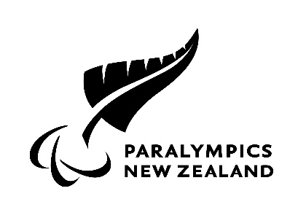

Updated on 31 August 2021

PNZ GUIDELINES and HEALTH AND SAFETY PLAN FOR COVID-19
ALERT LEVEL 4

The Government is leading our response to the COVID-19 pandemic and our goal is to ensure we meet national requirements. Onsite operations do not take place at Alert Level 4.

Outlined in this document are the Paralympics New Zealand (PNZ) Guidelines and Health and Safety Plans to prevent, detect, contain, and rapidly respond to COVID-19 related risks. We are all in this together, and whether you are a board member, employee, contractor, Para athlete, support team member there are some principles you must follow to help keep everyone safe as advised in August 2021 by the Prime Minister:

Alert Level 4 - Lockdown

- Stay at home in your bubble, other than for essential personal movement.
- Safe recreational activity is allowed in your local area.
- Travel is severely limited.
- All gatherings are cancelled and all public facilities close.
- If you are working for an Alert Level 4 business or service and you have no available options for childcare, you can extend your household bubble to include a carer for your children.
- Businesses close except for essential services, for example, supermarkets, pharmacies, clinics, petrol stations and lifeline utilities.
- Educational facilities close.
- Rationing of supplies and requisitioning of facilities possible.
- Reprioritisation of healthcare services is possible.
- Green grocers, butchers, bakeries, and fishmongers can sell uncooked food items online. All orders legally must be by delivery.

You are encouraged to wear a face covering whenever you leave the house. You legally must wear a face covering:
- on public transport and at departure points, for example airports, train stations and bus stops
- if you are a driver or passenger of a taxi or ride-share vehicle
- when you visit a healthcare facility (other than for a patient)
- inside retail businesses that are still open, such as supermarkets, pharmacies and petrol stations.

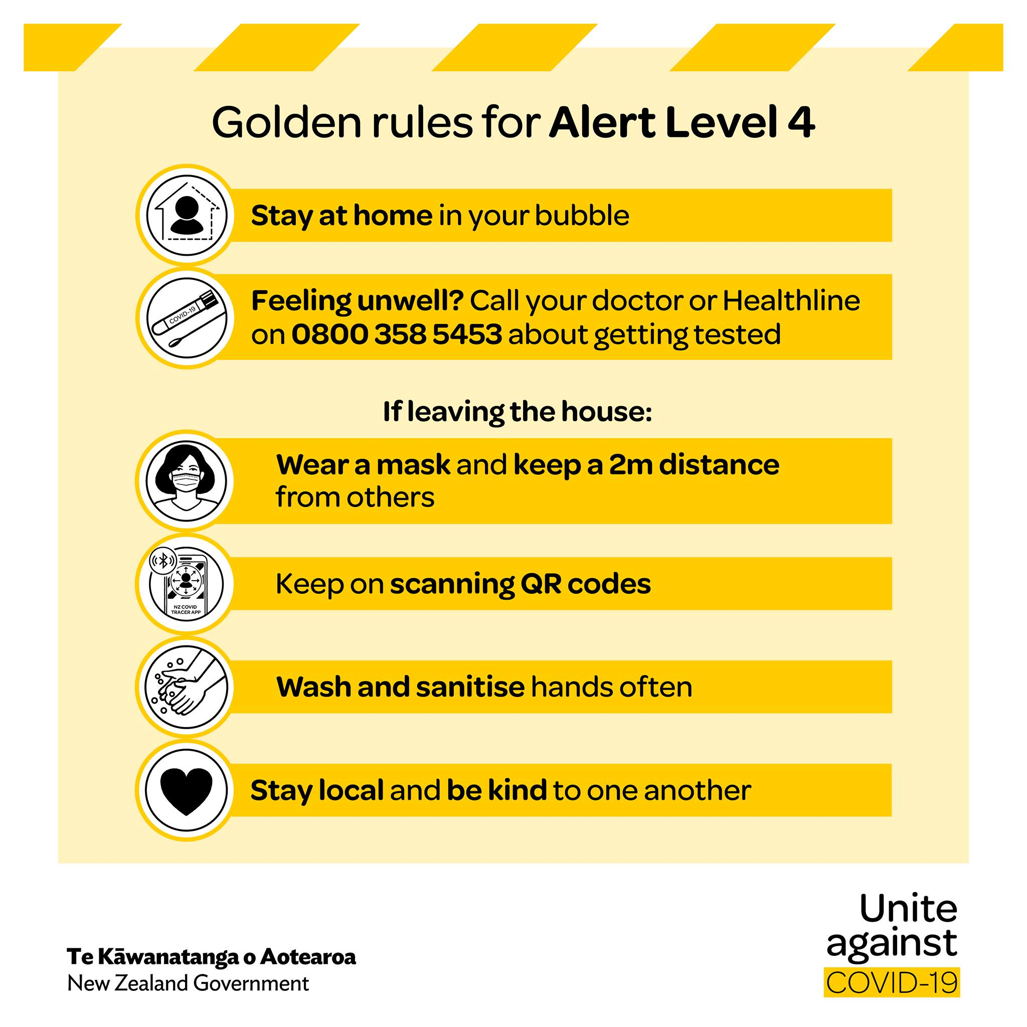

WHAT IS PNZ DOING AT COVID-19 ALERT LEVEL 4

At Level 4, COVID-19 is not contained, there is sustained and intensive community transmission of cases, and widespread outbreaks. PNZ will be reviewing all safety measures on a weekly/or as needed basis and adjusting where required to ensure that we are responding appropriately and effectively.

- The PNZ office is closed.

- HPSNZ training facilities and performance health centres will be closed with a “telehealth” approach. By “telehealth” approach this means all appointments will be by Microsoft teams (MT) or equivalent. Further action depending on how severe the performance health concern is will be confirmed. No person-to-person visits.
Strength and Conditioning services (S&C) are closed and if support is needed please contact respective S&C provider.

- Para athletes and support team members are required to liaise with their Programme Managers for guidance and monitoring.

- All Domestic travel is on hold until further notice.

- All international travel is on hold until further notice.

- All PNZ organised events are postponed or cancelled dependent on Government advice.

- For those experiencing anxiety or having welfare concerns please ensure you talk to either:
  - Manager/ Programme Manager
  - PNZ Psychologist, Rod Corban at rod.corban@gmail.com or 021 941 765

The PNZ COVID-19 Alert Level 4 guidelines are for:

- PNZ Auckland Office Personnel
- PNZ High Performance Programmes
- PNZ External Office Personnel and non-HPSNZ facilities
- HPSNZ Training Facilities and Performance Health Centres

- COVID-19 ALERT LEVEL 4 GUIDELINES FOR PNZ AUCKLAND OFFICE PERSONNEL
- The PNZ office is closed.
- Everyone is encouraged to stay at home and work from home.

- COVID-19 ALERT LEVEL 4 GUIDELINES FOR PNZ HIGH PERFORMANCE PROGRAMMES
- No PNZ Para Sport Programme training is taking place (i.e. for the Para sports of Para cycling, Para swimming and Shooting Para sport)
- All swimming pools, gyms, and facilities closed, and all group activities suspended
- Simple exercise, non-contact physical activity can take place, including in outdoor place that can be readily accessed from home.
- Do not start activities you have not tried before or are inexperienced in
- Low-risk activities only: care must be taken not to be injured and require medical care.
- No sharing of equipment outside your bubble
- All coaching and HPSNZ APS to be provided remotely
- No international or interregional travel for PNZ Para Sport Programmes.

- COVID-19 ALERT LEVEL 4 GUIDELINES FOR PNZ EXTERNAL OFFICE PERSONNEL AND NON-HPSNZ FACILITIES

- All public venues will be closed.
- Everyone is encouraged to stay at home and work from home.

- COVID-19 ALERT LEVEL 4 GUIDELINES FOR HPSNZ TRAINING FACILITIES AND PERFORMANCE HEALTH CENTRES

- HPSNZ offices will be closed.
- Training facilities and performance health centres will be closed. A telehealth approach will be taken.
- Let your Manager or Programme Manager know if you have concerns.

