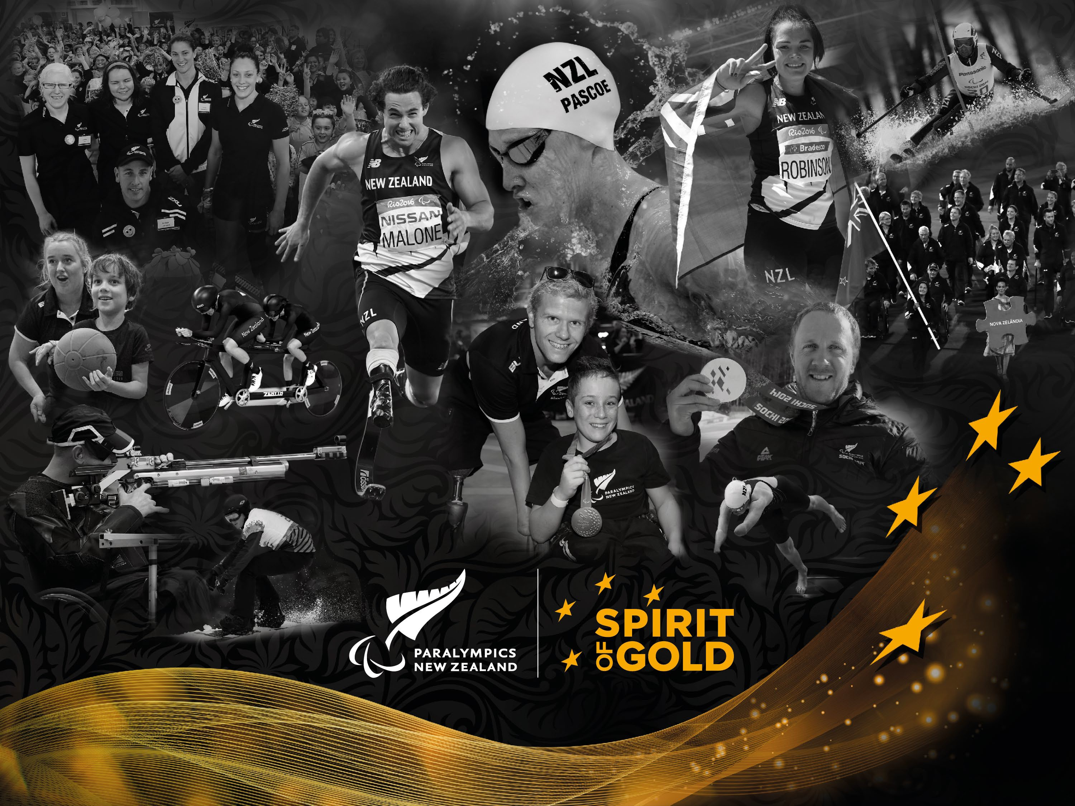

Collectively Stronger Together aims to drive national and regional collaboration that will get organisational role clarity, achieve strategic alignment, and capitalise on shared expertise to improve operating approaches and deliver on shared initiatives that strengthen, align and enhance community Para sport outcomes across New Zealand.

WHAT WILL BE DELIVERED

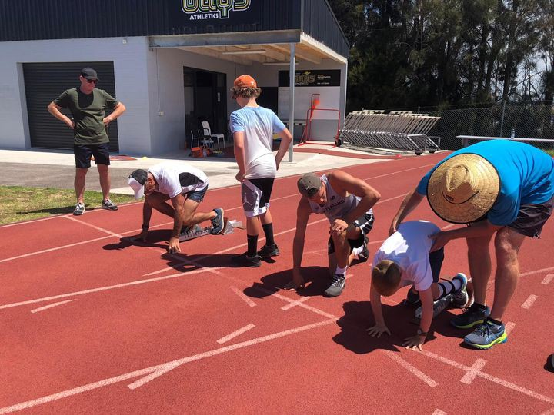This project has three components designed to better understand the Para sport landscape and increase collaboration and regional alignment: mapping the landscape, regional Para sport pilots, and strategic partnership and shared initiatives.

Mapping of the Para sport landscape:

- A Para Sport Community Manager will be recruited to build sector relationships while mapping the Para sport landscape.
- The primary focus of this role will be to engage with regional Parafed organisations and other community partners and champions.
- Further to this, the role will engage with other national disability organisations, regional Parafed organisations, NSOs and RSTs to capture details of the Para sport programmes and opportunities delivered by organisations for disabled New Zealanders of all ages.

Staging of the regional cross Para sport pilots:
- The Para Sport Community Manager will support all three pilots working alongside regional partners, NSOs/RSOs, NDSOs to co-design the pilots ensuring operational expertise in place to support each pilot partner. The three pilots to strengthen the regional delivery system for Para sport which will be consecutively implemented, one per year, to allow learnings to be transferred from one pilot to another to capitalise on improvement opportunities
- The first pilot will take place with an NSO that is more established and integrated in the Para sport space, as well as regional Parafed organisations.
- The second pilot will be rolled out with an NDSO.
- The third pilot with a NSO that has commenced and is in early stages of integration of Para sport delivery.
- Monitoring and evaluation of the pilots will take place throughout and a framework outlining best practice will be used to assist the co-design and development of future community Para sport partnerships and programmes.

Building strategic partnership and areas of alignment between PNZ and Parafed organisations:
- This is seen as integral to the success of this project. Working to co-design a shared vision and develop strategic alignments is a key component to achieving a stronger Para sport system. Service level agreements, and regular workshops will underpin the outcome – Collectively Stronger Together.
- Facilitate PNZ and regional Parafed organisations shared visioning and strategic priority alignment workshop.
- Co-design of shared community Para sport initiatives and development of service level agreements.
- Shared implementation, measurement and evaluation of agreed community Para sport initiatives.
- Facilitate PNZ and regional Parafed organisations workshop to co-evaluate
progress, further develop trusted relationships, and review strategic priorities.

