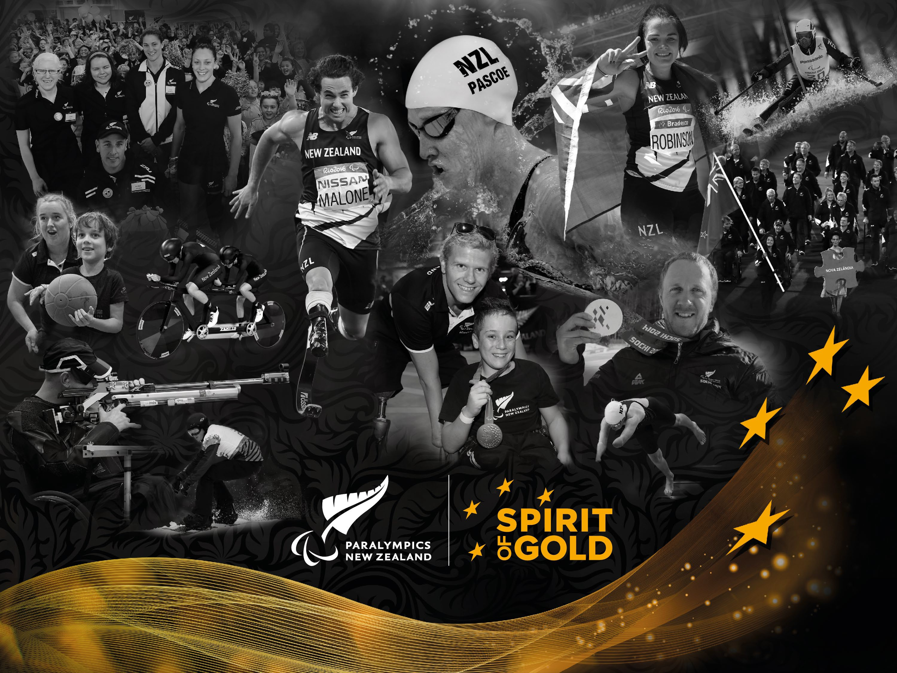

'Building the Para Sport Family' is a two-part system build project designed to support Para athletes and coaches through a Para Sport Collective and Para Sport Coach Development, delivering long-term system benefit.

WHAT WILL BE DELIVERED

The Para Sport Collective provides in-person camps and virtual support across all Para sports for Para athletes and coaches to build connections, confidence and knowledge through shared experiences and talent enrichment.

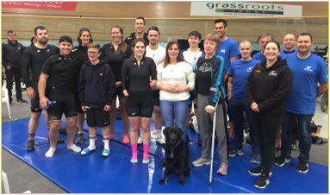
Coach Development will provide the resources for coaches across able-bodied and Para sport to gain knowledge, capability, confidence and creativity to coach and support Para athletes.

Para Sport Collective

- The Para Sport Collective is for Para athletes and coaches across the wide range of Para sports. Para athletes in the midrange of their Para sport talent journey (i.e. pre HPAD) where there is currently limited support are the target population group. The Project Lead will develop the Para Sport Collective to have an inclusive selection process ensuring an even balance of male and female athletes and coaches and, where appropriate, an emphasis on rangatahi.

- The central purpose of the Collective is connecting Para athletes and coaches while surrounding them with support and a range of learning and development opportunities.

- Over a 3-year period the Collective approach will include 5 national in-person camps (alternating between North Island and South Island locations to ensure accessibility) across two intakes and bi-monthly virtual connection opportunities. There will be two intakes over the period of the project.

Para Sport Collective continued:

- The Project Lead will co-design the Para Sport Collective needs with the PNZ Athletes Council, NSOs/NDSOs and coaches to understand current state and needs. This includes understanding and complementing anything being delivered at regional level in this space.

- A monitoring and evaluation framework will be developed to track the impact and outcomes of the Collective, as the basis for ongoing improvements. It is used to inform ongoing sustainability of the associated system change.

Coaching Development
- Development of coaching resources to address the stakeholder-reported lack of capability and confidence in supporting Para athletes.

- Development of stand-alone resources targeting Para sport coaches, with the ability to integrate Para sport and disability knowledge within non-abled coaching courses.

- During the development phase, PNZ would work with key stakeholders to co- design the resources and courses in a way that allows them to be incorporated/integrated within existing NSO coach development programmes.

- The resources would also be available to other organisations across the sport and recreation sector via Sport NZ's Sport Tutor learning portal.

- A monitoring and evaluation framework will be developed and used to inform ongoing sustainability of the associated system change.

