2021

Dear

Re: National Classification

Please find below the National Classification allocated to you by Paralympics New Zealand.

Sport | Sports Class | Sports Class Status

If you wish to have more information classification, please link to the following section on the Paralympics New Zealand website:
http://www.paralympics.org.nz/Pathway/Classification

If you wish to have more information on athlete pathways in Para sport, please contact Dale McDonald, PNZ Para sport Programme Support: DMacDonald@PARALYMPICS.ORG.NZ

I wish you good luck in your sporting career. Please feel free to contact me at any time if you require additional information.

Yours sincerely,
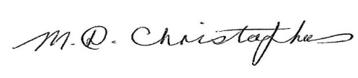

Marguerite Christophers

Classification Manager

Paralympics New Zealand

Mob: (021) 746727

Email: classification@paralympics.org.nz

