2021

Dear

Re: Provisional Classification

Many thanks for forwarding your provisional classification form to Paralympics New Zealand (PNZ). Please find below the provisional class allocated to you in accordance with the information submitted on your provisional classification test sheet.

Sport | Provisional Classification

Please note the following:

- A provisional classification is only an indication of your eligibility and potential sports class and may be subject to change.
- If you wish to receive a sport specific class, then a sport specific classification panel must assess you. Most national events have a classification panel. If you require further information on this please contact me at any time.
- Athletes with provisional classifications are not eligible for Paralympics New Zealand records.

If you wish to have more information classification, please link to the following section on the Paralympics New Zealand website:
http://www.paralympics.org.nz/Pathway/Classification

If you wish to have more information on athlete pathways in Para sport, please contact Dale McDonald, PNZ Para sport Programme Support:
DMacDonald@PARALYMPICS.ORG.NZ

I wish you good luck in your sporting career. Please feel free to contact me at any time if you require additional information.

Yours sincerely,

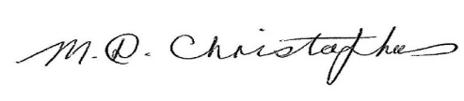

Marguerite Christophers
Classification Manager
Mob: (021) 746727
Email: classification@paralympics.org.nz

