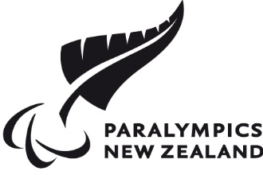

# Young People Aged 12 - 18 Para Sport Activation Fund 2021

# Background Information

Paralympics New Zealand (PNZ) has been granted funds from the Minister for Sport and Recreation’s Discretionary Fund to distribute to young people aged 12 – 18 with an impairment eligible for Para sport, or organisations supporting individuals aged 12 – 18 with an impairment eligible for Para sport, who couldn’t otherwise obtain funding to fund travel, equipment, subscriptions, access to facilities, coaching, camps and associated fees.

This information is designed to assist you in completing the application form.

The closing date for all applications is **4pm** on **Thursday 24 June 2021**

## Who can apply?

Young people (aged 12 – 18) with an impairment eligible for Para sport, or organisations supporting these individuals.

If you wish to seek eligibility, please email PNZ Classification Manager Marguerite Christophers: email [mchristophers@paralympics.org.nz](mailto:mchristophers@paralympics.org.nz) or phone 021 746 727 for more information.

## What can be applied for?

Funds to support the following items can be applied for:

* Travel
* Equipment
* Subscriptions
* Access to facilities
* Coaching
* Camps and associated fees

No retrospective funding will be considered.

## How do I apply?

Applicants must complete and submit the application form and provide quotes (if available).

PNZ suggests that you keep a copy of your application for your own records.

## Tips for a good application:

* Have you included 2 quotes (if available)?
* If you are not able to include 2 quotes, have you provided an explanation as to why?

## How do I know if I have been successful/unsuccessful?

Applicants will be notified in writing whether their application is successful or unsuccessful by **Friday 2nd July 2021**.

The selection panel’s decision is final.